(Title)

Ashil Sayyed Farahmand

Thesis submitted to the faculty of the Virginia Polytechnic Institute and State University in partial fulfillment of the requirements for the degree of

Master of Science
In
Electrical Engineering

Lamine Mili
Shinya Kikuchi
Daniel Stilwell

January 2008
Falls Church, VA

Keywords: collision avoidance, extended kalman filter, AVCS, advanced vehicle control systems, ITS, intelligent transportation systems

Copyright (Optional)
(Title)

Ashil Sayyed Farahmand

ABSTRACT

(Enter abstract here)

Acknowledgements

Contents

Acknowledgements iii
Contents iv
List of Figures vi
List of Tables vii
Acronyms viii
Chapter 1 - Introduction ix
1.1 Background ix
1.2 Problems/Limitations ix
1.3 Thesis Overview ix
Chapter 2 - Literature Review xi
2.1 Radar xi
2.2 Optical xi
2.3 Cooperative Collision Avoidance \ MAS(write as separate section?) xi
2.4 Other (Ships, Planes, Robots) xi
Chapter 3 - Model xii
3.1 Principles of Automobile Engines and Power Trains xii
3.2 Mathematical Model xiv
3.2.1 Control Variables xiv
3.2.2 State Variables xvi
Chapter 4 - Discretization, Linearization, and the Extended Kalman Filter xxiii
4.1 Kalman Filter (talk about recursive form) xxiii
4.1.1 Prediction xxiv
4.1.2 Correction\Update xxiv
4.2 Extended Kalman Filter xxiv
4.2.1 Prediction xxiv
4.2.2 Correction\Update xxiv
4.3 Numerical Integration Techniques xxiv
4.4 Discretization and Linearization Methods (I think I'm going to move this to one of the 4.2 sub-sections) xxiv
Chapter 5 - Stability xxv
5.1 Equilibrium Points xxv
5.2 Limit Cycles xxv
Chapter 6 - Vehicle Network xxvi
6.1 Wireless Networking Technologies (VANETs) xxvi
6.2 Cooperative Vehicle Optimization xxvi
6.2.1 Sparse Traffic xxvi
6.2.2 Dense Traffic xxvi
Chapter 7 - Simulation Results xxvii
7.1 Simulation Parameters xxvii
7.2 Determining the Brake Constant of Proportionality xxvii
7.3 Determining Deceleration as a Function of Brake Angle xxvii
7.4 Simulations of Sparse Traffic Optimization Algorithm xxvii
Chapter 8 - Conclusions xxviii
Chapter 9 - References xxix

List of Figures

Figure 1.1: A Roundabout (use captions) viii
Figure. 3.1: Normalized Throttle Characteristics with respect to Throttle Angle, plot of actual data and piecewise continuous fit copied from [1], plot of approximate fit overlaid. xiii
Figure. 3.2: Definition of Steering Angle xiv
Figure 3.3: Normalized Pressure Influence Function as a function of the Pressure Ratio. Plot obtained from [1]. xvi

List of Tables

Acronyms
AFI - normalized air fuel influence function
AFR - air/fuel ratio
DSRC - dedicated short-range communications
EKF - extended kalman filter
MBT - minimum spark advance for best torque
PR - pressure ratio
PRI - normalized pressure influence function
TC - normalized throttle characteristics
SA - spark advance/retard from top dead center
SI - normalized spark influence function

Chapter 1 - Introduction

1.1 Background
The invention of the automobile has allowed people to travel long distances at an unprecedented rate. Initially, vehicle ownership was limited to the rich. However, once mass production began in the 20th century, automobile ownership skyrocketed. The resulting traffic increase and contention at road junctions inspired the creation of new devices to prevent vehicle collisions. Roundabouts, stop signs, yield signs, and traffic signals began to be installed at intersections.

Roundabouts - how work, when to install them, different types

Figure 1.1: A Roundabout

Yield and Stop signs - how stop signs work, when to install them, when to upgrade to light

Traffic signal - timed, semi-actuated, fully actuated, when to install

1.2 Problems/Limitations
The existing intersection control devices are no good because they don't adapt.

1.3 Thesis Overview

(say something about coupled kalman filters)
The research conducted in this thesis seeks to improve upon the performance of current intersection control devices, specifically, traffic signals, stop signs, and yield signs, by proposing a decentralized, adaptive, cooperative collision avoidance system that acts as a traffic signal in dense traffic and as a yield sign in sparse traffic.

In an effort to improve upon other proposed collision avoidance systems that use linear, ideal models, each vehicle is modeled as a non-linear five state variable model that accounts for the vehicle's physical characteristics and internal engine parameters. The system has each vehicle measure its own state information using sensors. The state information of other vehicles is obtained by receiving data through a wireless communication link. An Extended Kalman Filter is then used to achieve a more precise estimate of the state information from these noisy measurements. The filtered state information is used to determine the optimal trajectory each vehicle should take to minimize the average delay of the vehicles in the intersection.
Chapter 2 - Literature Review

2.1 Radar

2.2 Optical

2.3 Cooperative Collision Avoidance \ MAS(write as separate section?)

2.4 Other (Ships, Planes, Robots)

Chapter 3 - Vehicle Powertrain Model

The first section of this chapter is intended to provide the reader a presentation of the physical operation of automobile engines and power trains. It is intended to be not a thorough discussion of all internal devices but to provide a sufficient background for understanding this thesis. The following section will present the differential equations governing the dynamics of the vehicle.

3.1 Principles of Automobile Powertrains
Conventional automobiles generate vehicle motion by burning a mixture of fuel and air. The internal combustion engine is responsible for converting the chemical energy of fuel into vehicle kinetic energy. The power train converts the output of the engine to the appropriate torque and rotational speed before transferring the power to the wheels. This section will provide a detailed discussion of how this process occurs.

The conversion process begins at the throttle. It adjusts the throttle valve which directly controls the amount of air being allowed into the engine's intake manifold. The intake manifold is responsible for regulating airflow to the individual engine cylinders. In naturally-aspirated engines, the pressure of the intake manifold never exceeds the ambient atmospheric pressure. (Discuss turbo + supercharging?) The pressure difference creates a stream of air through the manifold to the cylinders.

(Talk about engine cycle? intake/compression/power/exhaust) (If discussing cylinder configurations, insert here) The engine cylinders are the location where fuel combustion occurs. The cylinders receive air through a valve from the intake manifold. (Discuss fuel injection methods?) The electronic fuel injection (EFI) system mixes the fuel with the air prior to combustion. The type of EFI determines when the fuel is mixed with air. In sequential EFI (also known as multi-port fuel injection), fuel is injected at the exit of the intake manifold as air enters each cylinder for combustion.

The EFI system is also tasked with deciding the amount of fuel to inject. Using an oxygen sensor to measure the composition of gases in the exhaust, it adjusts the amount of fuel to achieve the optimal air/fuel ratio (AFR) during combustion. In terms of mass, an AFR of 14.7:1 results in complete combustion of air and fuel assuming the fuel is pure heptane. Different AFRs may be desired for a variety of reasons depending on the operating conditions.

After combustion occurs in the cylinders, the linear-reciprocating motion of the pistons is converted to rotational motion using a crankshaft. The crankshaft then connects to a flywheel. The flywheel acts as a stabilizing mechanism by smoothing the discrete firings of the pistons into a more continuous rotation. The engine angular velocity and output torque at the flywheel are often inappropriate for direct application to the wheels. The conversion to more appropriate values is performed by the transmission.

The transmission is composed of a gear box and typically in automatic transmissions a torque converter. The torque converter provides fluid coupling and increased torque during initial acceleration. It is composed of at least three rotating elements: a pump, a turbine, and a stator. The input of the converter, the pump, is directly connected to the engine and rotates at engine speed. The output of the converter, the turbine, is connected to the wheels through the gear box. The stator sits between the pump and turbine. When there is a substantial difference between the pump and turbine rotational velocities (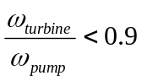), the torque converter is in converter mode. In this mode, the torque converter provides torque multiplication to the output by acting as an additional gear. When the pump and turbine angular velocities are nearly equivalent, the torque converter locks and is in fluid coupling mode [1]. The fluid coupling increases the fuel efficiency of the vehicle. Similar to the function of the flywheel, the fluid coupling also smoothes the rotational speed applied from the pistons to the wheels [Wikipedia].

The gear box of a typical car has four or five gears of fixed size. In an automatic transmission, the vehicle adjusts gears by itself. (Talk about different transmission types?) The gears are sized so that high torque is transferred to the wheels during low velocities and high rotational speed during high velocities. The highest gear is often called the overdrive gear. It significantly increases fuel efficiency at high speeds. When first introduced, the overdrive was a different device housed separately from the rest of the gears but in current vehicles the term is simply used to refer to the highest gear.

3.2 State Space Modeling
The state space vehicle model is based on tabulated data for a 1990 Lincoln Town Car. The model is basically a form of the 3 state variable model derived in [1] with portions from other sources that has been adapted for collision avoidance applications. The model vehicle is a typical 6 cylinder front-wheel drive car with a continuous four-stroke spark-ignition engine. The model used herein expands upon the original model and uses 3 control and 5 state variables.

3.2.1 Control Variables
The model's control variables represent the accelerator, brake, and steering wheel. The variables and their notations are shown in Table 3.1.
Table 3.1: Control Variables and Associated Notations.
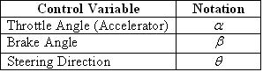

The throttle directly controls the air entering the intake manifold. Since the actual relationship between the two variables is highly non-linear, an approximate fit based on empirical data is used. The approximate fitted normalized throttle characteristic is defined as
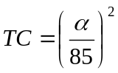. (1)

The effect of the throttle angle on the mass of air entering the intake manifold is shown in Fig. 3.1.

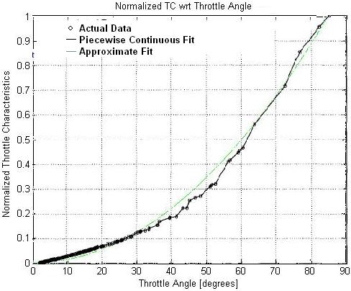

Figure. 3.1: Normalized Throttle Characteristics with respect to Throttle Angle, plot of actual data and piecewise continuous fit copied from [1], plot of approximate fit overlaid.

The brakes control the amount of pressure applied by the brake pads to the wheels. When the brakes are engaged, a torque opposing the motion of the car is created. In conventional vehicles, this causes the vehicle to dissipate energy in the form of heat and decelerate. Through simulations on the vehicle model used in this thesis, it was found that
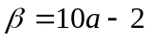 (2)

where  is in degrees and is the deceleration rate in m/s.

The steering direction controls the destination of the vehicle. Like the angles of the unit circle, it has been defined as the angle from the positive x₁ axis as shown in Fig. 3.2.

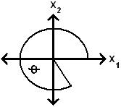

Figure. 3.2: Definition of Steering Angle

3.2.2 State Variables
The state variables of the vehicle are of a number of five; these include the x₁-coordinate position, x₂-coordinate position, mass of air in the intake manifold, engine angular velocity, and brake torque. The variables along with their notations are shown in Table 3.2.
Table 3.2: State Variables and Associated Notations
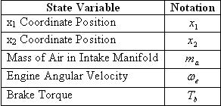

Each vehicle determines its position using GPS. When vehicles come within wireless communication range, each periodically shares its states along with other necessary information with the others. Since these measurements are noisy and communication packets may be lost in transit, it is useful to independently track other vehicles' positions by using velocity for comparison with the GPS measurements. This is carried out as follows: the velocity of a vehicle is given by
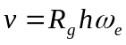, (3)

where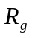 is the gear reduction ratio, a gear-dependent constant, and h is the effective tire radius. Using this equation, it follows that the differential equations for the x₁ and x₂ positions are given by
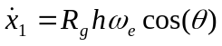, (4)
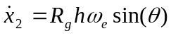. (5)

The differential equation for the next state variable, the mass of air in the intake manifold, is given by
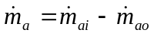, (6)

where 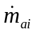 and 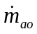 are the mass flow rates of air in and out of the intake manifold. The mass flow rate of air into the intake manifold is dependent on the throttle angle and the pressure difference between the atmosphere and the intake manifold. These dependencies are reflected in its equation
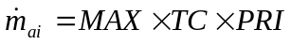. (7)

MAX, a vehicle-dependent constant, is defined as the maximum flow rate of air corresponding to a fully opened throttle valve. The effect of the throttle angle is represented by the normalized throttle characteristic defined in Equation 1. PRI, the normalized pressure influence function, represents the effect the pressure difference has on the incoming mass flow rate. A plot of 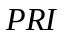 for the specific vehicle used in this thesis is shown in Fig. 3.3.
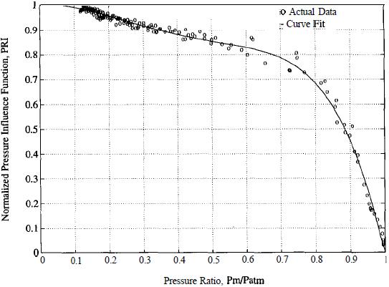

Figure 3.3: Normalized Pressure Influence Function as a function of the Pressure Ratio. Plot obtained from [1].

Due to its non-linear nature, the curve fit in Figure 3.3 has been used. Its functional form is given by the polynomial
(8)

where 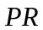 is the pressure ratio. is defined as the ratio between the pressure in the intake manifold and the atmosphere and is given by
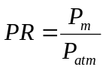. (9)

Using the Ideal Gas Law, the manifold pressure is given by
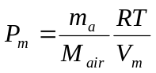 (10)

where  is the ideal gas constant, is the manifold temperature, 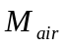 is the molecular mass of air, and 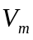 is the volume of the intake manifold.

Now that 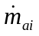 has been analyzed, the differential equations governing the mass flow rate of air exiting the manifold will be studied. Since the air leaving the manifold is directly used for combustion, its mass is dependent on the amount of work the engine is performing. The differential equation for the mass flow rate of air leaving the intake manifold is
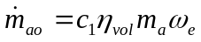 (11)

where 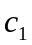 is a physical constant and 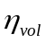 is the volumetric efficiency [1]. is given by
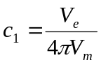 (12)

where 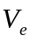 is the constant engine displacement. The volumetric efficiency describes the engine's ability to draw fresh air into the cylinders for combustion. It is a measure of the percentage of air and fuel that is drawn into the cylinder relative to the maximum amount that can be drawn during static conditions [Wikipedia]. It is common for fuel-injected vehicles to achieve efficiencies greater than 90%. Due to the difficulty of precisely modeling the volumetric efficiency, an empirical approximation is used instead. The approximation is given by the equation
[2]. (13)

The engine angular velocity is the next state variable to be analyzed. It is directly controlled by the brake angle and is indirectly controlled by the throttle angle through 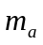. It is also directly proportional to the vehicle speed. Using Newton's Laws, the engine angular velocity is given as the solution of
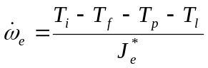 (14)

where 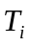 is the engine indicated torque, 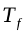 is the engine friction torque, 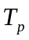 is the engine pump torque, 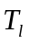 is the load torque, and 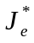 is the effective engine inertia. The torque variables in Equation 14 represent a variety of forces acting on the vehicle. represents the gross power generated by combustion in the engine cylinders. includes internal friction in the engine and power train while accounts for losses in the torque converter. The load torque is dependent on a number of factors including the amount of pressure on the brakes, the rolling resistance of the vehicle, and aerodynamic drag. The effective engine inertia is a gear dependent constant given by
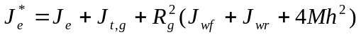 (15)

where 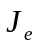 is the engine and torque converter inertia, 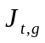 is the transmission inertia in gear (a gear dependent constant), 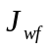 and 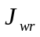 are the combined inertias of the front and rear wheels respectively, and  is the mass of the vehicle. The equation yielding the engine indicated torque is
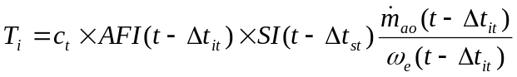 (16)

where 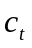 is the engine torque constant (the maximum torque capacity of an engine for a given air mass and engine speed), 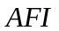 is the normalized air fuel influence function, 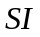 is the normalized spark influence function, 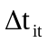 is the intake-to-torque production delay, and 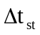 is the spark-to-torque production delay [1]. Assuming negligible time delays associated with engine power production, Equation 16 simplifies to
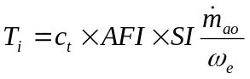. (17)

The normalized air fuel influence function is directly dependent on the AFR and is given by
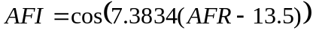. (18)

models the effect that ignition spark timing has on the engine torque production. The normalized spark influence function is given by
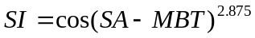 (19)

where 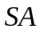 is the spark advance/retard from top dead center and the constant 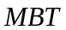 is the minimum spark advance for best torque [2]. Now that the engine's torque generation has been studied, the sources of energy loss are analyzed. The engine friction torque has been approximated from empirical data and is given by
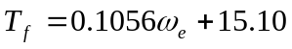 [2]. (20)

The torque converter's torque in converter mode is given by
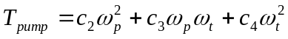 (21)
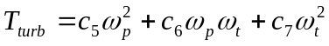 (22)

where 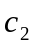 through 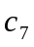 are constants. As the converter locks and transitions to fluid coupling mode, the torques become equal and are given by
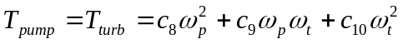 (23)

with 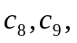 and 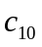 as constants. Since the pump rotates at the engine angular velocity and the turbine rotates as at the same rate as the pump in fluid coupling mode, the torque equation simplifies to
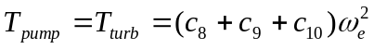. (24)

The final torque in the engine angular velocity differential equation, the load torque, is given by
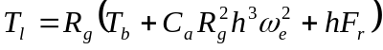 (25)

where 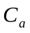 is a constant accounting for the aerodynamic drag coefficient and the constant 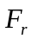 is the combined rolling resistance of the wheels.

The final state variable, the brake torque, is now analyzed. Unlike the other states, the brake torque is described by the following linear differential equation:
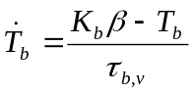. (26)

The brake torque constant of proportionality, 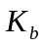, is directly related to the sensitivity of the brakes to pressure from the brake pedal. 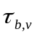, the brake system time constant, models the delay between pressure on the brake pedal and the application of the brake pads to the wheels.
Chapter 4 - Discretization, Linearization, and the Extended Kalman Filter

The Kalman Filter is a mathematical tool that estimates state information from noisy measurements. This chapter will introduce the Kalman Filter and discuss its governing equations. In the next section, the Extended Kalman Filter (EKF) will be presented and its application to the research conducted in this thesis will be explained. The following sections will discuss specific implementation methods.

4.1 Kalman Filter (talk about recursive form)
The Kalman Filter is a discrete-time, time domain filter used to estimate the states of linear, dynamic systems. Each iteration, it predicts the next state of the system using all past observations, receives a new observation corrupted by noise, then makes a corrected estimate of the system's state by comparing the new observation to all past observations. The filter models each state transition as
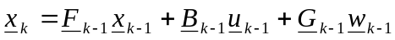 (27)

where is the state vector, 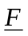 is the state transition matrix, 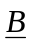 is the ??? matrix, is the control vector, 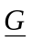 is the ??? matrix, and 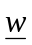 is the process noise. The state transition matrix describes how the system states change when no external inputs are applied. It is a significant indicator of the system's stability. The B matrix is. The G matrix is. The process noise is a vector of white normally-distributed random variables with zero mean. Its covariance is defined by the matrix 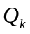. The Kalman Filter models each observation as
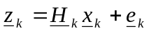 (28)

where 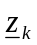 is the observation vector, 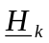 is the ??? matrix, and 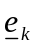 is the observation noise.

4.1.1 Prediction

4.1.2 Correction\Update

4.2 Extended Kalman Filter
The EKF differs from the Kalman Filter by its primary use in estimating the dynamics of non-linear systems. The filter works best when the system is only slightly non-linear.

4.2.1 Prediction

4.2.2 Correction\Update

4.3 Numerical Integration Techniques
Numerical integration techniques are a suitable alternative to basic analytical integration in situations where certain non-linear equations make finding analytical solutions impossible. In this section, the Euler and Runge-Kutta methods are examined.
- Euler Method
- Runge Kutta Method

4.4 Discretization and Linearization Methods (I think I'm going to move this to one of the 4.2 sub-sections)

Chapter 5 - Stability
This chapter will analyze the stability of the vehicle state equations. The results

5.1 Equilibrium Points

5.2 Limit Cycles

Chapter 6 - Vehicle Network
This chapter will

6.1 Wireless Networking Technologies (VANETs)

6.2 Cooperative Vehicle Optimization

6.2.1 Sparse Traffic

6.2.2 Dense Traffic

Chapter 7 - Simulation Results

7.1 Simulation Parameters
- T
- Mair
- How did you choose the EKF update frequency?
Why did you set parameters as such. Validate assumptions and show derivations for T, Mair….

7.2 Determining the Brake Constant of Proportionality
how Kb was determined

7.3 Determining Deceleration as a Function of Brake Angle

7.4 Simulations of Sparse Traffic Optimization Algorithm
- for the intersection topology and the vehicles. The topology is a flat, two-dimensional space with no elevation modeled after an intersection.
Chapter 8 - Conclusions
- Talk about future research topics
- more recent, more detailed mechanical model (hybrid)

Chapter 9 - References
[1] Berkeley PATH engine paper
[2] Supplemental Berkeley engine paper

